IMTSquare Company

AnyChange Software

Use Cases and Use Case Model

v1.1

**Revision History**

|  |  |  |  |
| --- | --- | --- | --- |
| **Date** | **Version** | **Description** | **Author** |
| 02/04/2022 | 1.0 | Draft 1 | IMTSquare Company |
| 09/04/2022 | 1.1 | Corrections are made based on reviews | IMTSquare Company |

**Contents**

Use Case Model 1

Use Case UC1: Register to System 2

Use Case UC2: Login to System 3

Use Case UC3: Manage Personal Information 4

Use Case UC4: Manage Payment Information 5

Use Case UC5: Manage Account 6

Use Case UC6: Monitor Products 7

Use Case UC7: Manage Notification 8

Use Case UC8: Search Product 9

Use Case UC9: Manage Product 10

Use Case UC10: Request Support 11

Use Case UC11: View Historical Data 12

Use Case UC12: Manage Support Requests 13

Use Case UC13: Manage Users 14

# Use Case Model

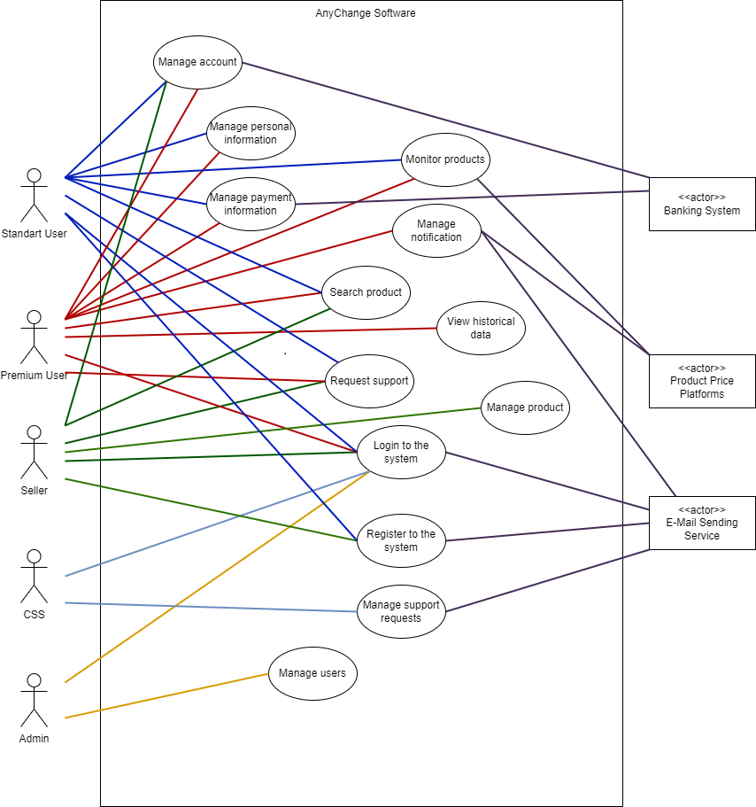

# Use Case UC1: Register to System

User wants to register to the system. System displays registration screen. User enters username and password. System validates the information and completes registration.

**Scope:** AnyChange Software

**Level:** User Goal

**Primary Actor**: Standard User, Seller

**Preconditions**: System is available and registration screen is loaded.

**Success Guarantee (Post Conditions)**:

Registration process is completed successfully and the system saves the new account correctly.

**Main Success Scenario:**

1. User wants to register.
2. System displays registration screen.
3. User enters the following details in the registration screen.
4. Username
5. Password
6. System validates that the username is not already in use and the password is in appropriate format. Then the system connects to “E-mail Sending Service” and sends a confirmation e-mail and displays confirmation page and waits for confirmation.
7. User enters confirmation password.
8. System validates the password and displays login page.

**Extensions:**

**\*a.** At any time, system fails:

1. System displays an error message and cancels the registration process.

**4a.** Validation is invalid because of username is already in use or password is inappropriate:

1. System displays an error message.
2. User enters different username or password according to the error message.
3. Flow continues from step 4 of the main success scenario.

**5a.** User rejects confirmation or doesn’t enter the confirmation password:

1. System cancels the registration process and directs user to the main page.

**Special Requirements:**

1. Username should be an e-mail address.
2. Password should be at least 8 characters and should contain at least one special character.
3. Confirmation password should be entered in 120 seconds.

# Use Case UC2: Login to System

User wants to login to the system. System displays login page. User enters username and password. System validates the information and completes registration.

**Scope:** AnyChange Software

**Level:** User Goal

**Primary Actor:** Standard User, Premium User, Administrator, Seller, Customer Service Staff

**Preconditions**: System is available and login page is loaded and the user is already registered to the system.

**Success Guarantee (Post Conditions)**:

System validates the account and login process is completed successfully and the system directs user to the inner home page.

**Main Success Scenario:**

1. The user wants to login to the system.
2. System displays login screen and waits for the username and password information.
3. The user enters his/her username and password.
4. The system validates the username and the password and directs the user to the inner home page.

**Extensions:**

**\*a.** At any time, system fails:

1. System displays an error message and cancels the login process.

**3a.** User forgets his/her password:

1. System displays a verification screen and waits for the registered username.
2. User enters his/her registered username.
3. System validates the username is already registered.
   1. If the validation is invalid extension scenario continues from step 2 until the validation is completed successfully.
4. System connects to “E-mail Sending Service” and sends an e-mail to the registered username *(which is an e-mail address belongs to the user)* that includes a password reset link.
5. User clicks the link.
6. System displays a screen and waits for a new password.
7. User enters a new password.
8. System validates the password and saves the new password successfully.
   1. If the validation is invalid extension scenario continues from step 7 until the validation is completed successfully.

**4a.** Validation is invalid because of username or password is invalid:

1. System displays an error message.
2. Flow continues from step 3 of the main success scenario.

# Use Case UC3: Manage Personal Information

User wants to manage the personal information. System displays personal information page. User configures information. System saves the updates and displays new information successfully.

**Scope:** AnyChange Software

**Level:** User Goal

**Primary Actor:** Standard User, Premium User

**Preconditions:** User successfully logins to the system and personal information page is loaded successfully.

**Success Guarantee (Post Conditions)**:

System saves and displays the updated information successfully.

**Main Success Scenario:**

1. User wants to manage personal information.
2. System displays personal information page that includes name, surname, address, phone number, password fields.
3. User configures information.
4. System saves the updates and displays successfully.

**Extensions:**

**\*a.** At any time, system fails:

1. System displays an error message and cancels the update request.
2. User restarts the system.

**3a.** User wants to change password:

1. System waits for current password and a new password.
2. User enters both password information.
3. System validates the current password and the new password. Then system saves the new password and flow continues from step 4 of the main success scenario.
   1. If the validation is invalid extension scenario continues from step 1 until the validation is completed successfully.

**Special Requirements:**

1. Phone number should be checked according to phone number regex.
2. Current password and new password shouldn’t be same.
3. KVKK confirmation should be taken.
4. Phone number and address information are necessary for billing operations and customer support issues.

# Use Case UC4: Manage Payment Information

User wants to manage the payment information. System displays payment information page. User adds a new credit card information or removes a saved record. System saves the updates and displays new information successfully.

**Scope:** AnyChange Software

**Level:** User Goal

**Primary Actor:** Standard User, Premium User

**Preconditions:** User successfully logins to the system and payment information page is loaded successfully.

**Success Guarantee (Post Conditions)**:

System saves and displays the updated information successfully.

**Main Success Scenario:**

1. User wants to manage payment information.
2. System displays payment information page.
3. User wants to add a new credit card information and enters card number, expiration date and security code.
4. System validates that the given credit card information does not belong to a different user and saves the new credit card information.

*User repeats steps 3-4 until all indicates done.*

**Extensions:**

**\*a.** At any time, system fails:

1. System displays an error message and cancels the request.
2. User restarts the system.

**3a.** User wants to remove a saved credit card record:

1. User selects a record to remove.
2. System displays a message and waits for confirmation.
3. User gives confirmation.
4. System removes the selected record. And the flow continues from step 4 of the main success scenario.

**4a.** Validation is invalid because of missing information:

1. System displays an error message.
2. Flow continues from step 3 of the main success scenario.

**Special Requirements:**

1. Each credit card should belong to one user, but a user can add one or more credit cards.
2. Card number, expiration date and security code should be checked according to the regex.
3. Credit card information should be encrypted.

# Use Case UC5: Manage Account

User wants to manage the account. System displays account information page. User wants to change account type or remove account. System saves the updates and displays new information successfully.

**Scope:** AnyChange Software

**Level:** User Goal

**Primary Actor:** Standard User, Premium User, Seller

**Preconditions:** User successfully logins to the system and account information page is loaded successfully and user adds at least one credit card information to the system.

**Success Guarantee (Post Conditions)**:

System checks payment and saves new account type and displays the updated account information successfully.

**Main Success Scenario:**

1. User wants to manage account information.
2. System displays current account information.
3. User wants to switch to the premium account.
4. System displays different premium account types that user can switch.
5. User selects an account type.
6. System lists the credit cards registered in the system.
7. User selects a credit card.
8. System waits for confirmation to continue the process.
9. User gives the confirmation.
10. System connects to the Banking System, sends necessary payment information and checks the payment response from the Banking System and saves the new account type of the user.

**Extensions:**

**\*a.** At any time, system fails:

1. System displays an error message and cancels the request.
2. User restarts the system.

**3a.** User wants to remove account:

1. System displays a message and waits for confirmation.
2. User gives confirmation.
3. System removes the account and deletes all personal data and directs user to the out of the system.

**3b.** User wants to switch standard account:

1. System displays a message and waits for confirmation.
2. User gives confirmation.
3. System saves the cancellation request and switches the account type to standard account after the expiration date of the premium account.

**6a.** There is no registered credit card for the user:

1. System shows an error message and cancels the request and directs the user to the payment information page.

**8a.** Payment response returns false:

1. System displays an error message and cancels the payment operation and the flow continues from step 2 of the main success scenario

**Special Requirements:**

1. Premium account is renewed automatically until the user switches to standard account or removes the account.
2. Each credit card should belong to one user, but a user can add one or more credit cards.
3. Card number, expiration date and security code should be checked according to the regex.
4. There should be three types of premium account: monthly, semi-annual and annual
5. Sellers can’t change the account type, they can only remove their account.

# Use Case UC6: Monitor Products

User wants to monitor products. System displays the list of the products. User selects one or more products to monitor. System displays the necessary information of the selected products.

**Scope:** AnyChange Software

**Level:** User Goal

**Primary Actor:** Standard User, Premium User

**Preconditions:** User successfully logins to the system and there are some products already added to the system and product list is loaded successfully and connection between price platforms works

**Success Guarantee (Post Conditions)**:

System displays the product list, connects to the price platforms, and brings the most up-to-date prices and other detailed information for the selected products successfully.

**Main Success Scenario:**

1. User wants to monitor products.
2. System presents the registered product list in the system and shows some brief information about products.
3. User selects one or more products to monitor detailed information about the selected products.
4. System connects to each platform and displays the actual prices of the selected products and other detailed information in each price platform and for each seller.

**Extensions:**

**\*a.** At any time, system fails:

1. System displays an error message.
2. User restarts the system.

**4a.** User wants to remove one or more products from the list:

1. User selects one or more products to remove from the list.
2. System removes the selected products and updates the list.

**4b.** User wants to add one or more products:

1. System presents the product list and the flow continues from step 3 of the main success scenario.

**4c.** Connection fails for one or more price platforms:

1. System shows a message about connection status and displays the last prices saved in the system for each product.

**Special Requirements:**

1. System should connect at least two different price platforms.
2. Even if no user triggers it, the system should record the price information of all registered products into the system on a daily basis.

# Use Case UC7: Manage Notifications

User wants to manage notification configuration. System displays the list of the registered products in the system. User selects one or more products to configure notification properties. System saves the notification configuration for each selected product and sends notification to the user successfully.

**Scope:** AnyChange Software

**Level:** User Goal

**Primary Actor:** PremiumUser

**Preconditions:** User logins the system and notification configuration page is loaded and notification via e-mail structure works successfully.

**Success Guarantee (Post Conditions)**:

System saves the notification configuration for each product that user selected and sends e-mail to the user according to the configuration successfully.

**Main Success Scenario:**

1. User wants to manage notification configuration for one or more products.
2. System lists the registered products.
3. User selects one or more products to configure notification properties.
4. System displays different notification options such as period based or price limit based or availability based.
5. User selects one or more notification options and enters necessary information according to selection *(for example: if period based notification is selected, user should enter the period value)*.
6. System saves the notification configuration for each product and sends notification correctly to the user according to the configuration via e-mail.

**Extensions:**

**\*a.** At any time, system fails:

1. System displays an error message and cancels the operation.
2. User restarts the system.

**4a.** User wants to remove the registered notification configuration:

1. System displays the saved notification configuration for selected products.
2. User removes the notification configuration.
3. System displays a confirmation message and waits for confirmation.
   1. If the user doesn’t give confirmation, the system cancels the removal request and the flow continues from the step 2 of the main success scenario.
4. System removes the notification configuration for selected products.

**Special Requirements:**

1. Period value should base on days and it can be at least 1 and at most 10 days.
2. If user selects more than one notification option, notification should be sent after all options are met. In other words, the link between the selected options must be “AND” based.

# Use Case UC8: Search Products

User wants to search a specific product among the list of the registered products in the system. System displays different filtering option to the user. User selects one or more filters and enters necessary information for filtering. System searches in the registered products and displays the result successfully.

**Scope:** AnyChange Software

**Level:** User Goal

**Primary Actor:** Standard User,PremiumUser, Seller

**Preconditions:** There are registered products in the system and products list page is loaded successfully

**Success Guarantee (Post Conditions)**:

System displays different filtering options and takes the filtering request and shows the result correctly.

**Main Success Scenario:**

1. User enters to the product list page.
2. System lists the registered products in the system.
3. User wants to search a specific product among all the products.
4. System displays filtering options such as product name or seller or price platform or price limit or availability or product category or brand.
5. User selects one or more filtering options and enters necessary information for filtering.
6. System shows the result according to the selected filtering options successfully.

**Extensions:**

**\*a.** At any time, system fails:

1. System displays an error message and cancels the request.
2. User restarts the system.

**3a.** Missing information for filtering:

1. System displays an error message and waits for the all necessary filtering information.

**4a.** If theresult is empty:

1. System displays a message and the flow continues from the step 2 of the main success scenario.

**Special Requirements:**

1. If user selects more than one filtering option, system should display the result that meets all the options. In other words, the link between the selected filtering options must be “AND” based.

# Use Case UC9: Manage Products

Sellers wants to manage products. System displays the current products of the seller. Seller adds a new product or removes/updates a product. System saves the request and updates the product list of the seller successfully.

**Scope:** AnyChange Software

**Level:** User Goal

**Primary Actor:** Seller

**Preconditions:** Seller successfully logins to the system.

**Success Guarantee (Post Conditions)**:

System saves the new product or updates the product’s information or removes from the list successfully.

**Main Success Scenario:**

1. Seller wants to manage products.
2. System displays the current product list of the seller.
3. Seller wants to add a new product.
4. System shows the necessary fields for adding a new product such as product name, brand, category, price, the amount of stock and some other optional fields.
5. Seller enters all the necessary fields and optionally enters unnecessary fields.
6. System checks the fields and saves the product and updates the product list in the system.

**Extensions:**

**\*a.** At any time, system fails:

1. System displays an error message and cancels the request.
2. User restarts the system.

**3a.** Seller wants to remove a product:

1. Seller selects a product to remove.
2. System displays a message and waits for confirmation.
3. Seller gives the confirmation.
   1. If the seller doesn’t give confirmation system cancels the removing request and the flow continues from the step 2 of the main success scenario.
4. System removes the product and updates the product list of the seller.

**4a.** Seller wants to update any product:

1. Seller selects a product to update.
2. System displays the current information about the selected product.
3. Seller updates the field(s) that he/she wants to change.
4. System displays a message and waits for the confirmation.
5. Seller gives the confirmation.
   1. If the user doesn’t give confirmation system cancels the updating request and the flow continues from the step 2 of the main success scenario.
6. System updates the product’s information.

**6a.** System’s check result is false:

1. System displays an error message about the uniqueness of the brand and product name and the flow continues from the step 5 of the main success scenario.

**Special Requirements:**

1. Entered brand and product name should be considered together and it should be unique for any product.

# Use Case UC10: Request Support

User wants to request a support. System displays the customer support page. User enters the detail of the problem and sends it. System saves the request at the “waiting for review” status successfully.

**Scope:** AnyChange Software

**Level:** User Goal

**Primary Actor:** Standard User,PremiumUser, Seller

**Preconditions:** User successfully logins to the system and customer support page is loaded.

**Success Guarantee (Post Conditions)**:

System saves the requests at the “waiting for review” status successfully.

**Main Success Scenario:**

1. User wants to request a support about the system.
2. System displays the customer support page.
3. User creates a new support request and enters the detail of the problem.
4. System saves the request at the “waiting for review” status successfully.

**Extensions:**

**\*a.** At any time, system fails:

1. System displays an error message and cancels the request.
2. User restarts the system.

**3a.** User wants to cancel any opened request:

1. User selects an opened request from the list and cancels it.
2. System displays a message and waits for confirmation.
3. User gives the confirmation.
   1. If the user doesn’t give confirmation system cancels the removing request and the flow continues from the step 2 of the main success scenario.
4. System cancels the request and updates the list.

# Use Case UC11: View Historical Data

User wants to see historical data for any product. System displays the product list in the system. User selects a product and enters the time period. System filters the data according to the given period and displays the result successfully.

**Level:** User Goal

**Primary Actor:** PremiumUser

**Preconditions:** PremiumUser successfully logins to the system and there are registered products in the system and time based product prices data is saved.

**Success Guarantee (Post Conditions)**:

System filters the data and shows the result correctly.

**Main Success Scenario:**

1. User wants to see historical data for a product.
2. System displays the registered products in the system.
3. User selects a product and enters the time period for filtering the data.
4. System filters historical price data for given time period and displays to the user.

**Extensions:**

**\*a.** At any time, system fails:

1. System displays an error message and cancels the request.
2. User restarts the system.

**4a.** User wants to change the time period:

1. System displays the given time period.
2. User enters the new values.
3. System filters data for new time period values and displays to the user.

**4b.** If theresult is empty:

1. System displays a message and the flow continues from the step 2 of the main success scenario.

**Special Requirements:**

1. System should save price data for six months. End date of the period is current date as default.

# Use Case UC12: Manage Support Requests

CSS wants to reply a support request. System displays the customer support page and lists the requests. CSS selects an opened request record. System shows the detail of the request. CSS replies the request and sends it to the user. System saves the answer and updates the status of the request and sends the answer to the user via e-mail.

**Level:** User Goal

**Primary Actor:** Customer service staff

**Preconditions:** CSS successfully logins to the system and customer support page is loaded.

**Success Guarantee (Post Conditions)**:

System saves the answer and changes the status of the request and sends it to the user successfully.

**Main Success Scenario:**

1. CSS wants to manage support requests.
2. System displays customer support page and lists the requests.
3. CSS selects a record at the “waiting for review” status.
4. System shows detail of the selected record.
5. CSS enters the answer for the selected record and sends it to the user.
6. System saves the answer and updates the status of the selected record as “answered” and connects to “E-Mail Sending Service” and sends the answer to the user via e-mail.

**Extensions:**

**\*a.** At any time, system fails:

1. System displays an error message and cancels the request.
2. User restarts the system.

**5a.** CSS wants to reject the request:

1. System displays a message and waits for confirmation.
2. CSS gives the confirmation.
   1. If the CSS doesn’t give confirmation system cancels the rejection request and the flow continues from the step 4 of the main success scenario.
3. System updates the status of the selected record as “rejected”

**Special Requirements:**

1. “rejected” or “answered” requests are closed to update. Only the details of them can be seen by the CSS and the owner of the request.

# Use Case UC13: Manage Users

Admin wants to manage users or permissions of roles in the system. System displays the roles in the system. Admin adds new user or removes a user or modify the role of a user or changes permissions of roles in the system. System saves the operation and updates the user list and permissions.

**Level:** User Goal

**Primary Actor:** Administrator

**Preconditions:** There is at least one admin user in the system and admin user successfully logins to the system.

**Success Guarantee (Post Conditions)**:

System saves the operation and updates the user list and permissions successfully.

**Main Success Scenario:**

1. Admin wants to manage users.
2. System displays the roles in the system.
3. Admin selects a role and add new user to this role.
4. System waits for entering data for necessary fields to continue the process.
5. Admin enters the necessary data.
6. System saves the new user and connects to “E-Mail Sending Service” and sends an e-mail that includes necessary information to login to the system.

**Extensions:**

**\*a.** At any time, system fails:

1. System displays an error message and cancels the request.
2. User restarts the system.

**3a.** Admin wants to remove a user:

1. System displays the users in the selected role.
2. Admin selects one or more user to remove.
3. System displays a message and waits for confirmation.
4. Admin gives the confirmation.
   1. If the admin doesn’t give confirmation system cancels the removing request and the flow continues from the step 2 of the main success scenario.
5. System checks the operation and removes the selected users from the role.
   1. If the process is done, it is checked whether there will be at least one admin in the system. And if the result is false system cancels the removing request and the flow continues from the step 2 of the extension scenario 3a.

**3b.** Admin wants to change the role of a user:

1. System displays the users in the selected role.
2. Admin selects one or more user to remove.
3. System displays a message and waits for confirmation.
4. Admin gives the confirmation.
   1. If the admin doesn’t give confirmation system cancels the removing request and the flow continues from the step 2 of the main success scenario.
5. System checks the operation and updates the role of the selected user.
   1. If the process is done, it is checked whether there will be at least one admin in the system. And if the result is false system cancels the removing request and the flow continues from the step 2 of the extension scenario 3b.

**3c.** Admin wants to change permissions or account expiration date a user:

1. System displays the users in the selected role.
2. Admin selects one or more user to modify.
3. System displays a message and waits for confirmation.
4. Admin gives the confirmation.
   1. If the admin doesn’t give confirmation system cancels the update request and the flow continues from the step 2 of the main success scenario.
5. System saves the update and connects to “E-Mail Sending Service” and sends an e-mail to the user according to the changes.

**Special Requirements:**

1. Only CSS and admin users can be added or removed by the admin.
2. There should be at least one “Administrator” in the system.
3. Admin can give permission to any standard user to access some features accessible by premium users.
4. Admin can change the account expiration date of any premium user.